Africa Tech Festival Awards 2023
Nominations open for the African tech industry’s best of the best

Johannesburg, 24 August 2023 – TAKING place at the Bay Hotel in Camp’s Bay, Cape Town on 15 November 2023, the achievements of some of the African technology, telecommunications, and media industry’s most illustrious pioneers and tech entrepreneurs, will once again be fêted at the prestigious Africa Tech Festival Awards.

As awards ceremonies go, Africa Tech Festival’s are a standout, not only in their recognition of the achievements of the companies and people who are making a difference in the lives of countless Africans, but for their reputation as an unforgettable evening of fun, food, and conversation in the company of some of the industry’s hottest talent.

The Awards Ceremony will welcome Africa’s leaders to an elegant evening celebration beginning with a cocktail reception at Tides restaurant with its magnificent seafront views, followed by a gala dinner in the Rotunda accompanied by live music. The night will end with an afterparty soundtracked to a live DJ.
As encouragement to enter and commenting on the impact of winning the Start-up of the Year Award in 2022, Motunrayo Opayinka, founder of Womenovate says that it has: “brought significant visibility and recognition to Womenovate. As a result, we experienced various positive changes, including increased brand visibility and new collaboration opportunities. We were also able to expand our network with like-minded individuals, experts, and mentors, which for us is very valuable in our mission to support Nigerian women in STEAM.
“Winning the prestigious award added to our credibility, helping us to further gain trust from our stakeholders, beneficiaries, and the public.”
In 2023, the Africa Tech Festival team have taken the event up yet another notch, introducing a new award category – the Creative Visionary Award –to commend the remarkable forerunners in the African media, broadcasting, and entertainment industries.

Award Categories
Creative Visionary Award – this new award is dedicated to honouring exceptional media, broadcasting, and entertainment professionals across Africa.
Connecting for All Award – dedicated to recognising and honouring network providers and services that have demonstrated exceptional commitment and effort in ensuring connectivity for all.
Innovation for Impact – recognises innovations in products or services that have disrupted traditional approaches, introduced novel solutions, and created tangible value for businesses and individuals in Africa.
CXO of the Year – honours exceptional leaders in Africa and their outstanding contributions in building teams, setting new standards, and delivering on a clear vision in a rapidly changing business landscape.
Changing Lives Award – dedicated to recognising and honouring organisations and initiatives that are committed to improving lives across the continent.
Female Innovator of the Year Award – honours the women who have made significant contributions to the fields of tech, media, and telecoms across Africa.
Sustainability Champion of the Year – formerly the ‘Green ICT Champion Award’, this award celebrates the remarkable achievements of individuals or organisation leading the way in the development and integration of sustainable energy solutions for the continent.
Fintech Innovation Award – acknowledges the transformative power of financial technology in driving economic growth, financial inclusion, and digital transformation.
Start-up of the Year Award – acknowledges the entrepreneurial spirit, technological innovation, and potential impact of start-ups in driving growth, solving challenges, and contributing to the advancement of Africa’s tech ecosystem.
HealthTech Innovation of the Year Award – recognises innovative solutions that are changing lives, advancing healthcare, and making a significant positive impact on individuals and communities.
Overseeing the development of the awards and responsible for the overall festival’s successful delivery each year, James Williams, Director, Events | Connecting Africa | Informa Tech comments that: “These awards are all about celebrating the optimists in industry for whom every challenge is a possibility and a solution waiting to be discovered and implemented.

“The wealth of talent on the African continent is exceptional, which makes the public voting to select only one hero per category, a highly competitive process and extremely difficult. That said, it is an honour to be amongst them all and we look forward to this event every year and to sharing their achievements with our connected community.”

Nominations are open until 7 September 2023, with short-listed candidates announced on 11 September 2023. To enter, nominations need to be submitted on the Africa Tech Festival website. The short-listed candidates will be chosen by a panel of judges, and thereafter, the winners will be selected via a public vote.

For more information, please see website here: Africa Tech Festival 2023 - The Home of AfricaCom & AfricaTech

To register for a free visitor pass, please use this link. Pre-registration open here.

To register for media accreditation please use this link: Press Pass or see the Africa Tech Festival website and follow the links to our press zone.
(Please note that all requests are adjudicated and there may be some delay before you hear back from us).

For media enquiries, interviews and/or images please contact: Kaz Henderson kaz@networxpr.co.za or call on +27 (0) 82 339 1199.
Social Media Handles:
Facebook: @africatechfestival
Twitter: @africatechfest
LinkedIn: https://www.linkedin.com/showcase/africa-tech-festival/
//ends
Motunrayo Opayinka, founder of Womenovate

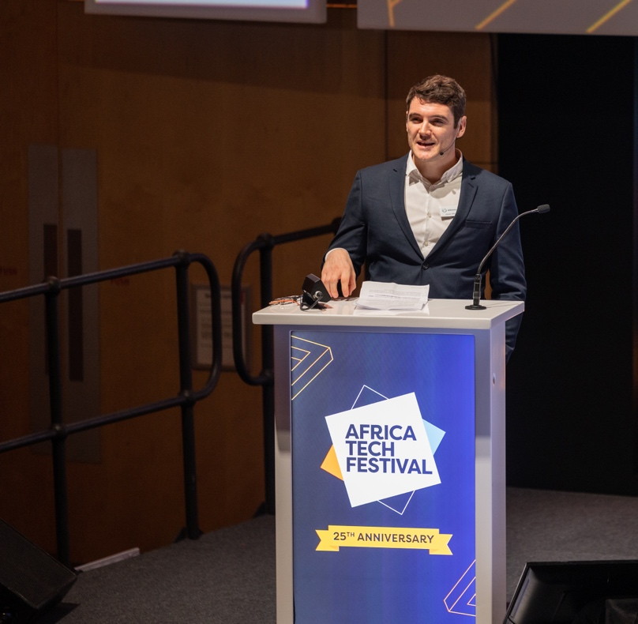
James Williams - Director, Events | Connecting Africa | Informa Tech

About Africa Tech Festival 2023
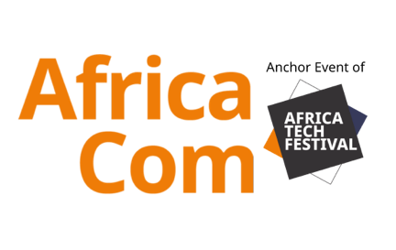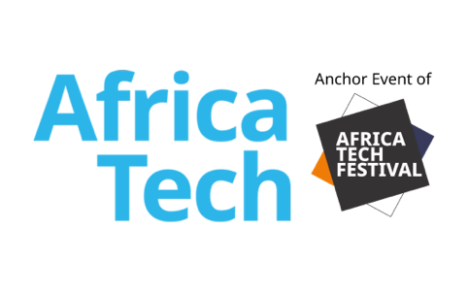
Africa Tech Festival, including anchor events AfricaCom, AfricaTech and AfricaIgnite is part of the Informa Tech Connecting Africa event series. A vibrant celebration of Africa’s diverse community of tech champions, Africa Tech Festival is the largest tech and digital connectivity conference and exhibition in Africa, attracting hundreds of exhibitors, more than 400 speakers and more than 12000 delegates.
Key themes for 2023 continue to explore the creation and sustainability of a connected Africa and the impact this can have for the people of the continent but also the commercial prospects for local and global businesses and governments. Topics will include Telcos of Tomorrow, Connecting the Next Billion, Digital Infrastructure Investment, Sustainability & Climate Resilience, ICT Policy and Regulation, Fintech & MFS, Broadcast Media & Entertainment, Pioneer Tech, the Future of Work and Talent and Skills Development. Africa Tech Festival also incorporates and the Africa Tech Festival Awards, an exclusive ceremony celebrating Africa’s tech pioneers and held at the luxury 5-star The Bay Hotel, as well as the LeadersIn Africa Summit, an exclusive, VIP-only feature offering high-level presentations and roundtable discussions to Africa’s tech elite.

